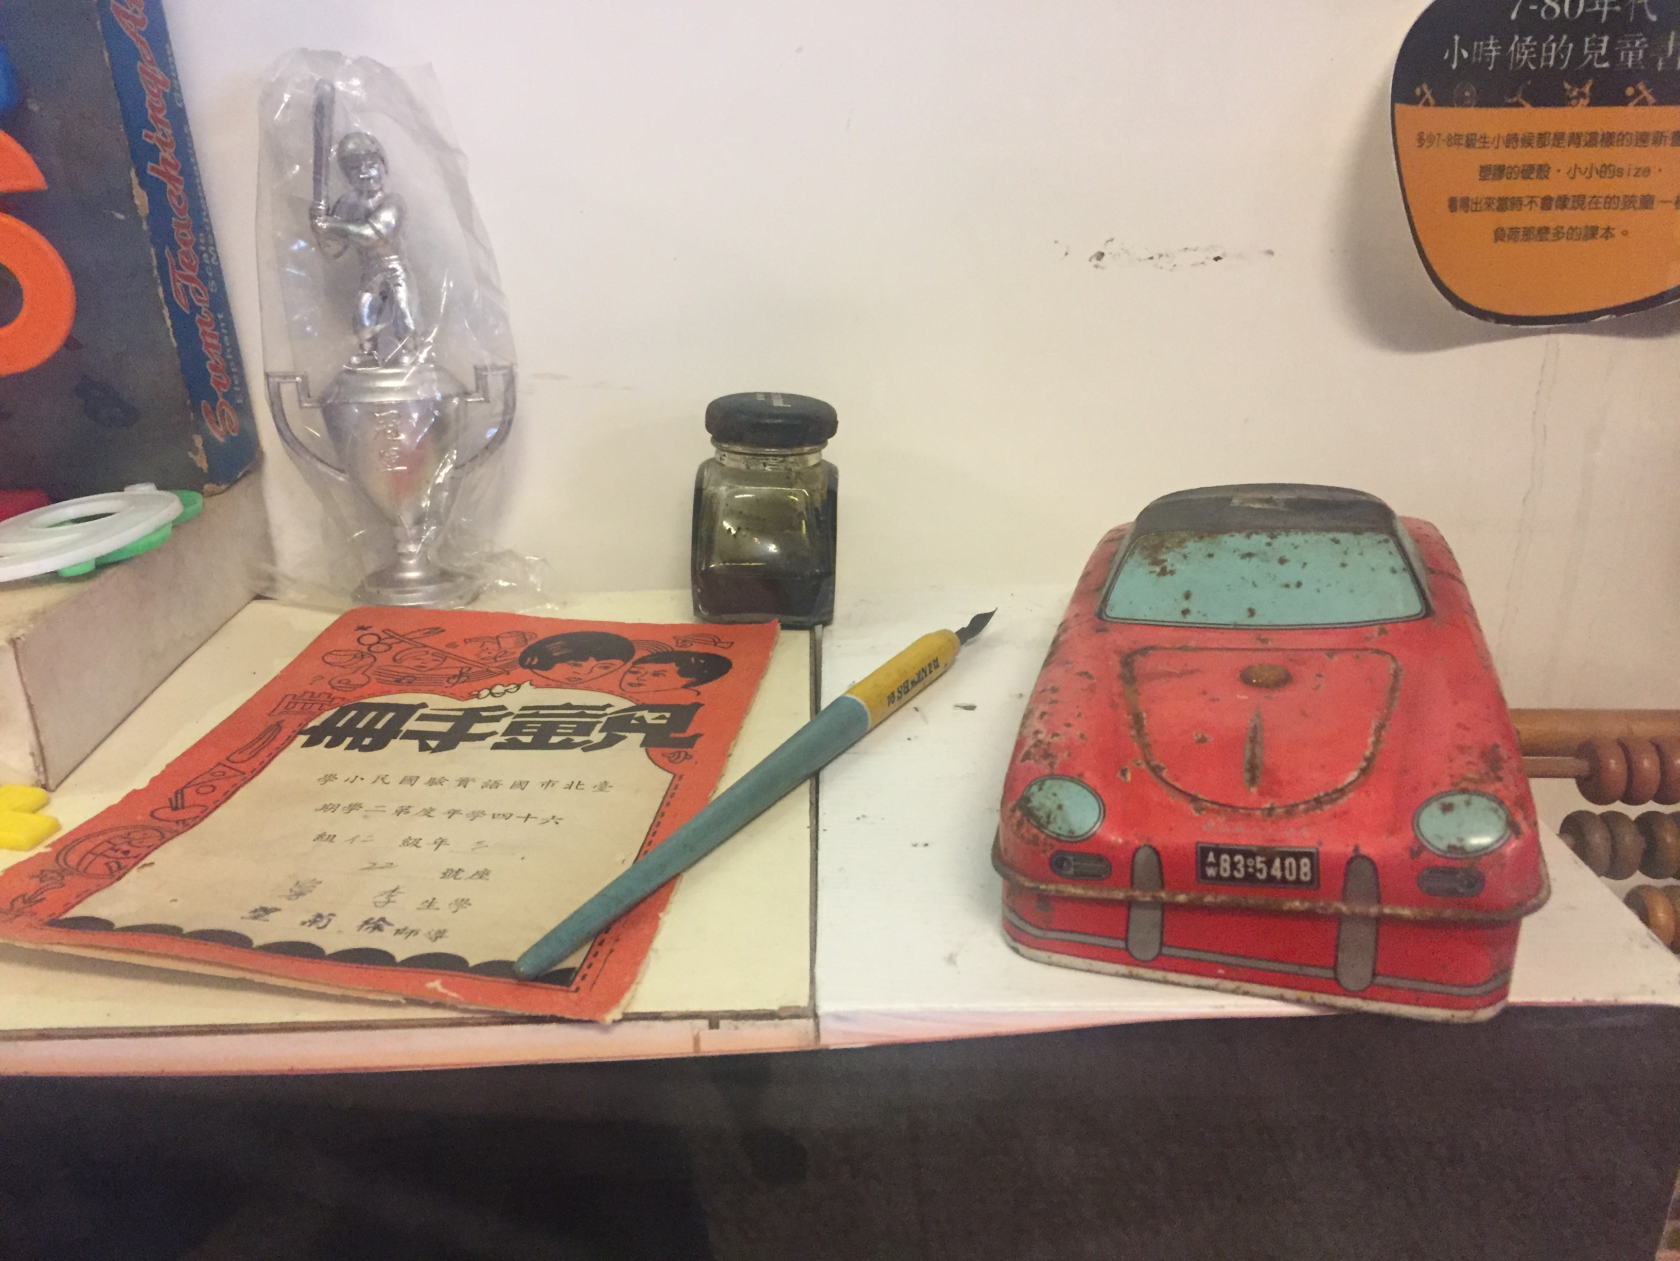

**C U R R I C U L U M V I T A E**

**D r. r e r. n a t. h a b i l. W o l f g a n g S c h m i d t** (施臥虎)

|  |  |  |  |
| --- | --- | --- | --- |
| Personal data | | | |
|  | **Professional titles** (before retiring from the academic world):   * Research Fellow at the IPMB, Academia Sinica, Taiwan * Adjunct Professor at National Taiwan University, Taiwan * Adjunct Professor at National Chung-Hsing University, Taiwan * Visiting Faculty at the Sabancı University Istanbul, Turkey * Assegnista di Ricerca at the Universitá degli Studi di Udine, Italy * Privatdozent (equivalent to Associate Professorship) at the University of Oldenburg, Germany * Hochschulassistent (equivalent to Assistant Professorship) at the University of Oldenburg, Germany | |
| Education | | | |
|  | Habilitation  Completion of the German habilitation procedure in September 1998 by the conferment of the *Venia Legendi* for Botany.  PhD  Dr. rer. nat. *summa cum laude* awarded in July 1992  Diploma  Diploma in Biology (grade 1.0) | |
| Research Interests | | | |
|  | Molecular Biology  Systems Biology  Signaling Networks  Development  Responses to Environmental Signals | |
| Awards (Selected)  Academia Sinica Investigator Award  Outstanding Research Fellow (Ministry of Science and Technology, Taiwan)  AAAS Fellow | | | |
| EDITORIAL ACTIVITIES   * + - * Editor (*Frontiers in Plant Science, Scientific Reports, Plant & Cell Physiology, Plant and Soil*       * Editor of the e-books *Peptide Signaling in Plants* (*Frontiers in Plant Physiology*), *Iron Nutrition and Interactions in Plants* (*Frontiers in Plant Nutrition*), and *Root Systems Biology* in (*Frontiers* *in Plant Systems Biology*)       * Editor of the Spotlight issue *Iron Nutrition and Interactions in Plants* (*Plant & Cell Physiology*)       * *Ad hoc* reviewer for *Cell*, *Science*, *Nature Communications*, *Nature Plants*, *PNAS*, *Trends in Plant* *Science*, *Plant Cell*, *Plant Physiology*, *New Phytologist, Plant Journal* and many, many more*.*   OTHER ACTIVITIES AND CONTRIBUTIONS | | | |
| * + - * Chair of the 19th International Symposium on Iron Nutrition and Interaction in Plants, Taipei, Taiwan, 2018       * Chair of the 1st International Symposium on Root Systems Biology, Taipei, 2012       * Member of the steering committee of the conference series ‘International Symposium on Iron Uptake and Interaction in Plants’ (since 2011)       * Board member of the Agence National de la Recherche (France)       * *Ad hoc* reviewer for *Cell*, *Science*, *Nature Communications*, *Nature Plants*, *PNAS*, *Trends in Plant* *Science*, *Plant Cell*, *Plant Physiology*, *New Phytologist, Plant Journal* and many, many more*.*       * Grant reviews for Academia Sinica, National Science Foundation (NSF; USA), Agence National de la Recherce (ANR; France), German Science Foundation (DFG; Germany), Ministero dell'Istruzione, dell'Università e della Ricerca (MIUR; Italy), Czech Science Foundation (GACR; Czech Republic), Danish Ministry of Higher Education and Science (Denmark), National Research, Development and Innovation Office (NRDI; Hungary) | |

Selected Publications

See for a complete list <https://scholar.google.com/citations?user=7f-GqoEAAAAJ&hl=en>

|  |  |  |
| --- | --- | --- |
| Vélez-Bermúdez IC, Schmidt W (2024). IRON MAN is a jack of all trades. *Nature Plants* 10: 703-705  Jain D, Schmidt W (2023) Protein phosphorylation orchestrates acclimations of Arabidopsis plants to environmental pH. bioRxiv 2023.03.19.533375 and *Molecular & Cellular Proteomics*, 23:100685  Schmidt W (2022) pH-sensing: Why plants can’t have it all. *Current Biology* 32: R1039-R1041  Vélez-Bermúdez IC, Schmidt W (2022) How plants orchestrate cellular iron homeostasis. *Plant & Cell Physiology* [63: 154-162](https://doi.org/10.1093/pcp/pcab166) (*Editor’s Choice*)  Schmidt W (2021) It’s all in the title. *FEBS Letters* 595:2641-2643  Tsai HH, Schmidt W (2021) The enigma of environmental pH sensing in plants. *Nature Plants* 7: 106-115  Gautam, C, Tsai, HH, Schmidt W (2021) **IRONMAN tunes responses to iron deficiency in concert with environmental pH. *Plant Physiology* 187: 1728-1745** (*Recommended by F1000*)  Grillet L, Schmidt W (2019) Iron acquisition strategies in land plants: Not so different after all. *New Phytologist* 224: 11-18  Schmidt W (2019) The Yin and Yang of iron in plants and beyond: 19th International Symposium on Iron Nutrition and Interactions in Plants (ISINIP) in Taiwan. *Plant & Cell Physiology* 60: 1401-1404  Grillet L, Lan P, Li W, Mokapati G, Schmidt W (2018) IRON MAN is a ubiquitous family of peptides that control iron transport in plants. *Nature Plants* 4: 953–963  Tsai HH,Schmidt W (2017) One way. Or another? Iron uptake in plants. *New Phytologist* 214: 500-505  Tsai HH, Schmidt W (2017) Mobilization of iron by plant-borne coumarins. *Trends in Plant Science* 22: 538-548  Salazar-Henao JE, Vélez-Bermúdez IC, Schmidt W (2016) The regulation and plasticity of root hair patterning and morphogenesis. *Development* 43: 1848-1858  Schmidt W (2015) Root development: Pulse control. *Nature Plants* 1: 15148  Lan P, Li W, Santi S, Schmidt W (2013) Mapping gene activity in Arabidopsis root hairs. *Genome Biology* 14: R67   |  |  | | --- | --- | |  |  | |